English Month in Bangla

January:

byte january1_1[8] = {0x00,0x02,0xFB,0x36,0xAB,0x9B,0xF6,0x00};
byte january1_2[8] = {0x00,0x00,0xFF,0x29,0xA5,0x6F,0xA1,0xD4};
byte january1_3[8] = {0x0E,0x51,0x7F,0xD3,0x55,0x53,0x55,0x00};

February:
byte february1_1[8] = {0x00,0x00,0xFF,0x66,0x95,0xA5,0x5E,0x01};
byte february1_2[8] = {0x00,0x00,0xFF,0x69,0xA5,0x6F,0x55,0xE8};
byte february1_3[8] = {0x0E,0x51,0x7F,0xD3,0x55,0x53,0x55,0x00};

March:

byte march1_1[8] = {0x00,0x00,0x07,0x02,0x01,0x03,0x03,0x00};
byte march1_2[8] = {0x00,0x11,0xDF,0x74,0x57,0xD4,0x57,0x00};
byte march1_3[8] = {0x80,0x00,0xC0,0x00,0x80,0x80,0x00,0x00};

April:
byte april1_1[8] = {0x00,0x00,0x0D,0x0A,0x02,0x26,0x1A,0x00};
byte april1_2[8] = {0x78,0x86,0xDB,0xA6,0x9A,0x92,0xC6,0x3A};
byte april1_3[8] = {0x00,0x00,0xFC,0x08,0x58,0xA8,0x88,0x00};

May:
byte may1_1[8] = {0x00,0x00,0x00,0x00,0x00,0x00,0x00,0x00};
byte may1_2[8] = {0x00,0x00,0xFF,0x52,0x8A,0x9E,0x5A,0x00};
byte may1_3[8] = {0x00,0x00,0x00,0x00,0x00,0x00,0x00,0x00};

June:
byte june1_1[8] = {0x00,0x00,0x0F,0x01,0x05,0x04,0x07,0x00};
byte june1_2[8] = {0x00,0x00,0xFF,0xC0,0x27,0xA4,0xD6,0x68};
byte june1_3[8] = {0x00,0x00,0xE0,0x40,0x40,0xC0,0x40,0x00};

July:
byte july1_1[8] = {0x00,0x00,0x3F,0x0E,0x29,0x25,0x3E,0x03};
byte july1_2[8] = {0x00,0x01,0xFD,0x07,0x2D,0x55,0x85,0x40};
byte july1_3[8] = {0xE0,0x10,0xFC,0x60,0x10,0x60,0x38,0x00};

August:
byte august1_1[8] = {0x00,0x00,0xFE,0x1B,0x56,0x46,0x3A,0x00};
byte august1_2[8] = {0x00,0x82,0xDB,0xA6,0x92,0xB2,0x82,0x00};
byte august1_3[8] = {0x98,0x64,0xFF,0x90,0x76,0x92,0x0C,0x00};

September:
byte september1_1[8] = {0x00,0x00,0xFF,0x52,0x8B,0x8F,0x5A,0x00};
byte september1_2[8] = {0x98,0x64,0xEF,0xD8,0x68,0x0A,0x8E,0x00};
byte september1_3[8] = {0x00,0x00,0xFF,0x53,0xF5,0x73,0x55,0x30};

October:
byte october1_1[8] = {0x00,0x00,0xFF,0x34,0xAD,0x8D,0x74,0x00};
byte october1_2[8] = {0x90,0x69,0xFD,0xBF,0x55,0x33,0x9D,0x00};
byte october1_3[8] = {0x00,0x00,0xFF,0x33,0x55,0x53,0x35,0x00};

November:
byte november1_1[8] = {0x00,0x00,0xFF,0x04,0x75,0x4D,0x64,0x00};
byte november1_2[8] = {0x00,0x00,0xFF,0x98,0x51,0x4C,0xB8,0x00};
byte november1_3[8] = {0x00,0x00,0xFF,0xA7,0xE9,0xE5,0xAB,0x60};

December:
byte december1_1[8] = {0x78,0x84,0xFF,0x88,0xAD,0xA5,0x9C,0x00};
byte december1_2[8] = {0x00,0x00,0xFF,0xA4,0x15,0x1C,0xB4,0x00};
byte december1_3[8] = {0x00,0x00,0xFF,0xA7,0xE9,0xE5,0xAB,0x60};

Bangla Month in Bangla

Boishakh:

byte boishakh1_1[8] = {0x60,0x10,0xFF,0x27,0x49,0x4D,0x23,0x00};
byte boishakh1_2[8] = {0x00,0x05,0xDD,0x27,0x55,0x05,0x05,0x00};
byte boishakh1_3[8] = {0x00,0x02,0xEB,0x7A,0x0A,0x32,0x0E,0x00};

joishtho:

byte joishtho1_1[8] = {0x30,0x08,0x7F,0x11,0x25,0x24,0x13,0x00};
byte joishtho1_2[8] = {0x00,0x00,0xFF,0xC5,0x28,0xA4,0xA8,0x00};
byte joishtho1_3[8] = {0x1C,0x20,0xFE,0x38,0xE4,0xA4,0x78,0x00};

Ashar:

byte ashar1_1[8] = {0x00,0x00,0xFE,0x1B,0x56,0x46,0x3A,0x00};
byte ashar1_2[8] = {0x00,0x81,0xFD,0xA7,0x95,0xAD,0x9D,0x00};
byte ashar1_3[8] = {0x00,0x00,0xFE,0x40,0x4C,0x44,0x38,0x10};

srabon:

byte srabon1_1[8] = {0x00,0x01,0x37,0x09,0x15,0x01,0x23,0x1D};
byte srabon1_2[8] = {0x00,0x40,0x7F,0xCE,0x52,0x5A,0x46,0x00};
byte srabon1_3[8] = {0x00,0x08,0x6C,0x98,0xC8,0x08,0x08,0x00};

Bhadro:

byte bhadro1_1[8] = {0x00,0x00,0x0F,0x00,0x04,0x02,0x01,0x00};
byte bhadro1_2[8] = {0x00,0x08,0xEF,0x59,0x89,0x69,0xCA,0x01};
byte bhadro1_3[8] = {0x00,0x00,0xF0,0x00,0x20,0xD0,0x90,0x60};

ashin:

byte ashin1_1[8] = {0x00,0x00,0xFE,0x1B,0x56,0x46,0x3A,0x00};
byte ashin1_2[8] = {0x1E,0xA1,0xFB,0xA4,0xAA,0xA1,0xA2,0x01};
byte ashin1_3[8] = {0x00,0x80,0xFF,0x82,0xBA,0xA6,0xB2,0x80};

kartik:

byte kartik1_1[8] = {0x00,0x00,0xFE,0x3D,0x4A,0x6A,0x18,0x00};
byte kartik1_2[8] = {0x1C,0xA3,0xFF,0xA3,0xAA,0xA8,0xA7,0x00};
byte kartik1_3[8] = {0x80,0x00,0xFF,0x1E,0xA5,0xB5,0x0C,0x00};

ogrohayon:

byte ogrohayon1_1[8] = {0x00,0x00,0x1F,0x03,0x0A,0x08,0x07,0x00};
byte ogrohayon1_2[8] = {0x00,0x00,0xF6,0x49,0xC4,0xCC,0x51,0x0E};
byte ogrohayon1_3[8] = {0x00,0x80,0xD8,0x98,0x80,0x98,0x98,0x00};

poush:

byte poush1_1[8] = {0x00,0x00,0x0E,0x05,0x08,0x08,0x04,0x00};
byte poush1_2[8] = {0xB8,0x54,0xDF,0x35,0xD4,0x95,0x14,0x00};
byte poush1_3[8] = {0x00,0x00,0xF0,0x20,0xA0,0x60,0xE0,0x00};

magh:

byte magh1_1[8] = {0x00,0x00,0x07,0x02,0x01,0x03,0x03,0x00};
byte magh1_2[8] = {0x00,0x10,0xDF,0x74,0x55,0xD2,0x53,0x00};
byte magh1_3[8] = {0x00,0x00,0xE0,0x40,0x40,0x40,0xC0,0x00};

falgun:

byte falgun1_1[8] = {0x00,0x00,0xFE,0x4D,0x2A,0x4A,0x38,0x00};
byte falgun1_2[8] = {0x00,0x80,0xF8,0x86,0xA9,0xD4,0x8D,0x01};
byte falgun1_3[8] = {0x00,0x80,0xFF,0x81,0x9D,0x93,0x59,0xA0};

choitro:

byte choitro1_1[8] = {0x06,0x01,0x0F,0x02,0x04,0x04,0x02,0x00};
byte choitro1_2[8] = {0x00,0x00,0xFF,0x81,0xF1,0x94,0xE3,0x00};
byte choitro1_3[8] = {0x00,0x00,0xF0,0xC0,0x20,0x60,0xA0,0x00};

Weekday In Bangla

Shonibar:

byte shonibar1_1[8] = {0x00,0x05,0xDF,0x25,0x55,0x05,0x05,0x00};
byte shonibar1_2[8] = {0xF0,0x08,0xFE,0x08,0x68,0x58,0x08,0x00};
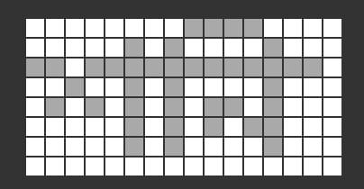

Robibar:

byte robibar1_1[8] = {0x01,0x02,0xFF,0x3A,0x4A,0x2A,0x5A,0x00};
byte robibar1_2[8] = {0xE0,0x10,0xFC,0x70,0x90,0x90,0x70,0x00};
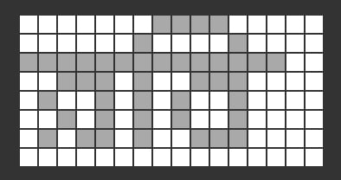

Shombar:

byte shombar1_1[8] = {0x00,0x00,0xFF,0x29,0x45,0x47,0x2D,0x00};
byte shombar1_2[8] = {0x00,0x40,0x7F,0xD2,0x4A,0x5E,0x5A,0x00};
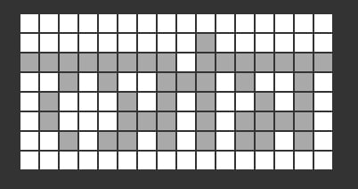

Mongolbar

byte mongol1_1[8] = {0x04,0x03,0xFA,0x99,0x56,0xF1,0xD3,0x00};
byte mongol1_2[8] = {0x00,0x40,0x7F,0xC1,0x4B,0x55,0x51,0x00};
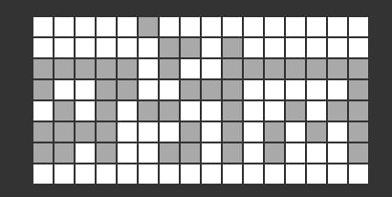

Budhbar:

byte budhbar1_1[8] = {0x01,0x02,0xFE,0x39,0x4A,0x39,0x14,0x0A};
byte budhbar1_2[8] = {0x00,0x00,0xF0,0x40,0x40,0xC0,0x40,0x00};
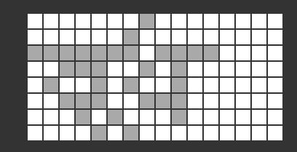

Brihoshpotibar:

byte briho1_1[8] = {0x00,0x00,0xD8,0x18,0x80,0x18,0xD8,0x00};
byte briho1_2[8] = {0x00,0x00,0xFF,0x3B,0x48,0x3B,0x11,0x1C};
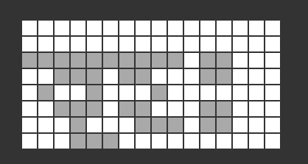

Shukrobar:

byte shukro1_1[8] = {0x00,0x02,0xDB,0x26,0x52,0x06,0x0A,0x05};
byte shukro1_2[8] = {0x00,0x00,0xFF,0x3C,0x4A,0x3A,0x98,0x68};

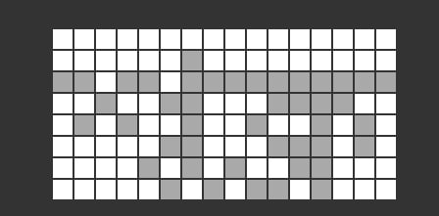

Number in Bangla

byte shunno_small_1[8] = {0x18, 0x24, 0x42, 0x42, 0x42, 0x42, 0x24, 0x18};
byte ek_small_1[8] = {0x60, 0x70, 0x1c, 0x06, 0x02, 0x62, 0x76, 0x3c};
byte dui_small_1[8] = {0x60, 0x7c, 0x06, 0x06, 0x7c, 0x60, 0x30, 0x1e};
byte tin_small_1[8] = {0x0c, 0x5a, 0x5a, 0x42, 0x42, 0x42, 0x42, 0x3c};
byte char_small_1[8] = {0x3c, 0x66, 0x66, 0x3c, 0x3c, 0x66, 0x66, 0x3c};
byte pach_small_1[8] = {0x30, 0x38, 0x46, 0x48, 0x4a, 0x46, 0x62, 0x3c};
byte chhoy_small_1[8] = {0x18, 0x58, 0x48, 0x4a, 0x4e, 0x42, 0x62, 0x3e};
byte shaat_small_1[8] = {0x38, 0x44, 0x44, 0x3c, 0x04, 0x04, 0x06, 0x06};
byte aat_small_1[8] = {0x60, 0x60, 0x26, 0x22, 0x3e, 0x24, 0x24, 0x38};
byte noy_small_1[8] = {0x60, 0x78, 0x0c, 0x06, 0x72, 0x4a, 0x6a, 0x0e};

